Reg. No.

Ph. D COURSEWORK EXAMINATION – SEPT/OCT 2023 SUBJECT: AEROSPACE ENGINEERING

SPECIALIZATION PAPER 1
AEROSPACE STRUCTURAL DYNAMICS
CODE: SPH1

Time: 03 hours Maximum Marks: 50
Student Name: Venkateswarlu

Instructions:
- Section A Compulsory
- Answer any four from Section B
- Each question carries 10 Marks

SECTION A

Answer the following question: (10 Marks)

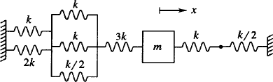
- a)Explain the Newton method, energy method and Relaygh method to find the natural frequency of vibrating systems, Determine the natural frequency for the system of springs mass connected as shown in fig(1) (5M)
fig (1)
b. A circular cylinder of mass m and radius r is connected by a spring of stiffness K, mass m as shown in fig (2). If it is free to roll on the rough surface which is horizontal without slipping, find its natural frequencies
(5M)
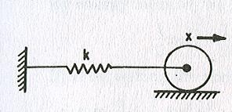
fig (2)

SECTION B

Answer any four from the following question: (Each carrying 10 Marks)

- Derive the governing differential equation for the spring mass damper system shown in fig(3) and also determine the time period of damped oscillations. (10M)

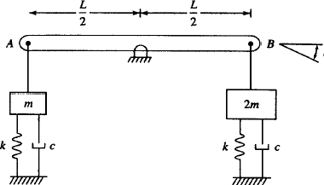
fig (3)
- Determine the axial natural frequencies of the circular shaft by consistent mass matrix approach. Consider the shaft is two equal length finite elements, length is L , cross sectional area is A, material Youngs modulus is E, fixed at one end and free at other end. (10M)

- Explain the Lagrangian equation for multiple degrees of free system and by using Lagrangian approach; write the equations of motion for the multi body spring mass, pendulum system as shown in fig(4) . Consider the mass of the pendulum rod was neglected, the roller is sliding and lumped mass pendulum oscillating, consider slider mass M. (10M)
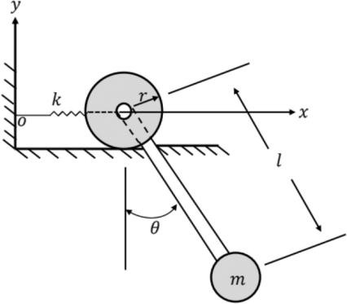
fig (4)
- Derive the general solution of onedimensional wave equation for continuous transverse vibrations of string. (10M)

- A cantilever beam of length L= 30 m, mass of the beam m = 6x10⁴ kg, youngs modulus of the beam material E = 2x10¹¹ N/mm², area moment of inertia I = 0.02 m⁴, is fixed at one end and free at other end, the deflection at a distance ‘x’ from the fixed end is given by y = y_{f} [1-(cosπx/2l)], Where y_{f} is deflection at free end, calculate the frequency of continuous vibrations using Rayleighs method. (10M)

- A machine part having a mass of 2.5 kg vibrates in viscous medium. A harmonic exciting force of 30N acts on the part and causes resonant amplitude of 14mm within a period of 0.22 seconds. Find the damping coefficient. If the frequency of exciting force is changed to 4 hertz, determine the increase in the amplitude of the forced vibrating system upon removal of the damper. (10M)

********

